Pointers (Part 2 Pointers with Arrays and Functions)

LAB # 09



Spring 2022

CSE-102L COMPUTER PROGRAMMING LAB

Submitted by: MUHAMMAD SADEEQ

Registration No.: 21PWCSE2028

Section: C

"On my honor, as student of University of Engineering and Technology, I have neither given nor received unauthorized assistance on this academic work.'

Student Signature: _____________________

Submitted to:

Engr. Abdullah Hamid

(July 2022)

Department of Computer Systems Engineering University of Engineering and Technology, Peshawar

# Lab 9: Pointers (Part 2 Pointers with Arrays and Functions)

## Objectives:

To understand pointer role in arrays and functions

## Tasks:

1. Write a C++ program where you make an array of 10 elements, user will enter values in the array and after entering you must display them. Entering the values and displaying the values must be done using a single pointer
2. Write a program to input twelve numbers from user using array and display all values on console (3 values in a row) (use separate loops for input and output operation). Use pointers to input values into the array and use pointer for outputting the values.

SAMPLE OUTPUT:

Value 1=?? Value 2=?? Value 3=??

Value 4=?? Value 5=?? Value 6=??

Value 7=?? Value 8=?? Value 9=??

Value 10=?? Value 11=?? Value 12=??

1. Write a program where you create a string array of size 2. Create a pointer that points to the array. Using pointer insert your name in the first element (must be using cin) then also insert your registration number in the second element. Display them both then using the pointer.
2. Write a program which calculates the average of an array of 5 elements (initialize the value during declaration) the average should be calculated in a function called average(), this function will have a pointer parameter (array must be passed here) and also an integer parameter (which is the size of array) i.e average(int *arr , int size).
3. Write a C++ program where you declare an array of 5 elements, create a pointer that points to the array also declare two integers, then ask the user to input values in the array (using pointer), after that ask the user again to input values into the two integers, the two integer values will act as the index of array (like if user enters 3,2 so arr+2, arr+1). Now finally send the two array indexes values to a function (the function must have two pointers as parameters). The function will add the two values on index locations and put them back in the first index/element of array. Cout the first index of array in main().
4. Write a C++ program where you create 4 functions (additions, subtraction, division, multiplication) and a 5th function called calculator() the calculator will have two integers and a pointer to function as a input. So for example if you execute int x = calculator(4,5,addition); in main() x value will become 9.

(this task was already done in lab)

**COMPUTER PROGRAMMING LAB # 9**

**Answer #1**

**CODE:** 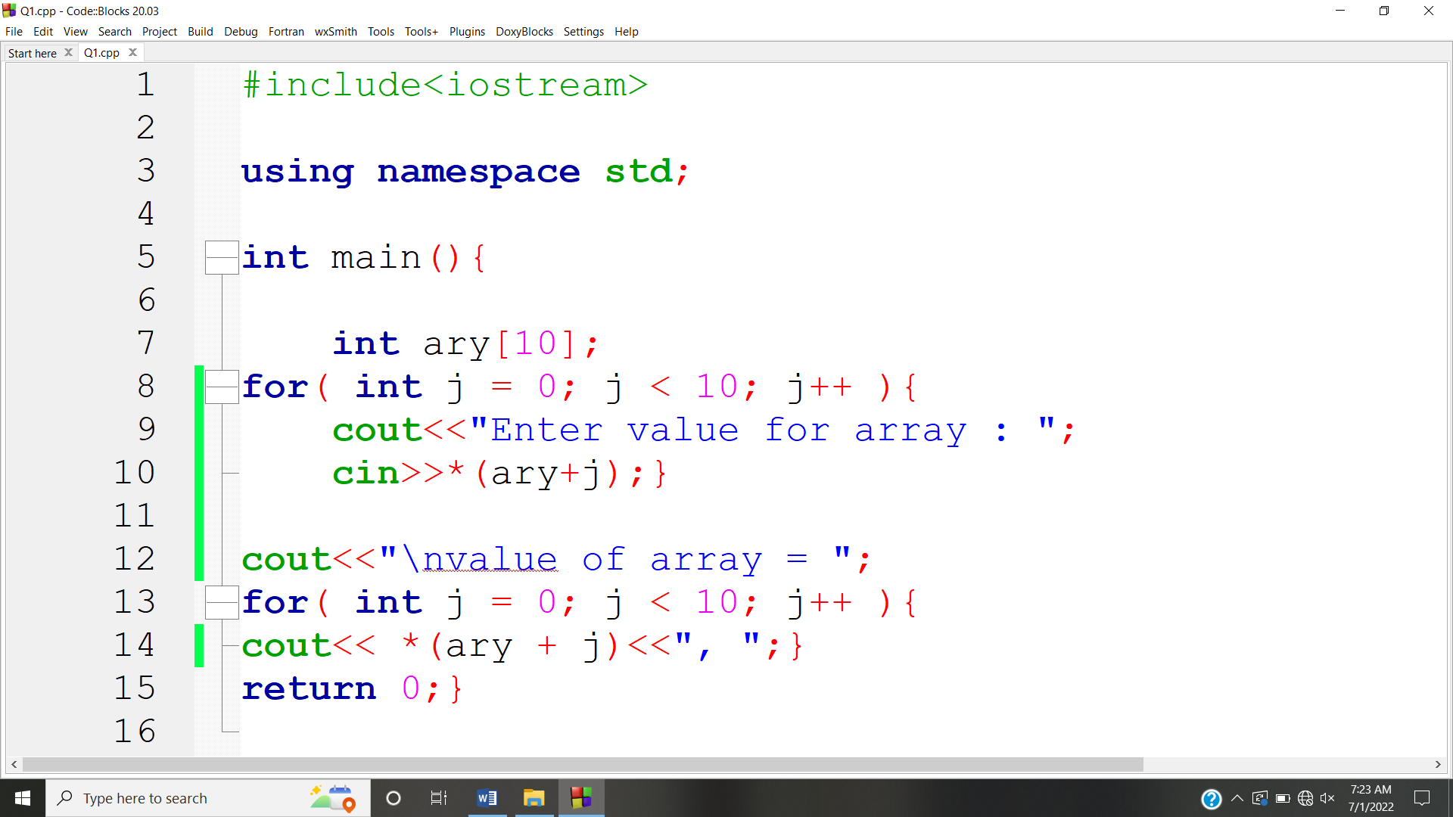

**OUTPUT:** 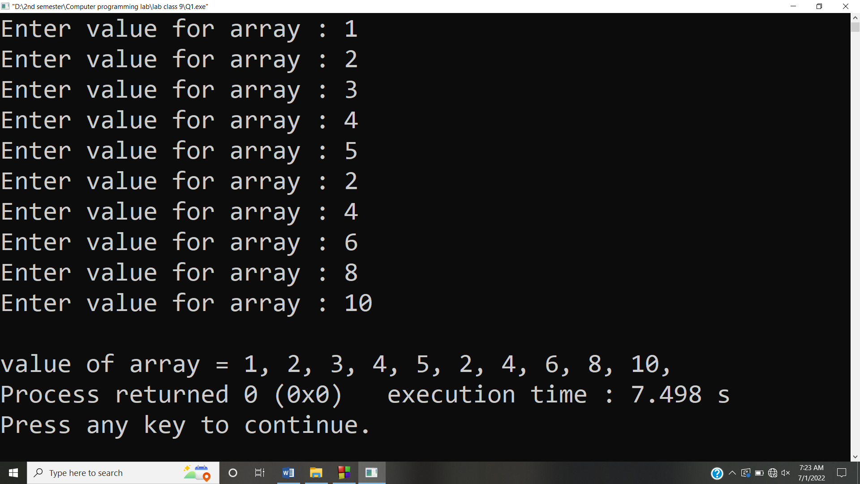

**Answer #2**

**CODE:** 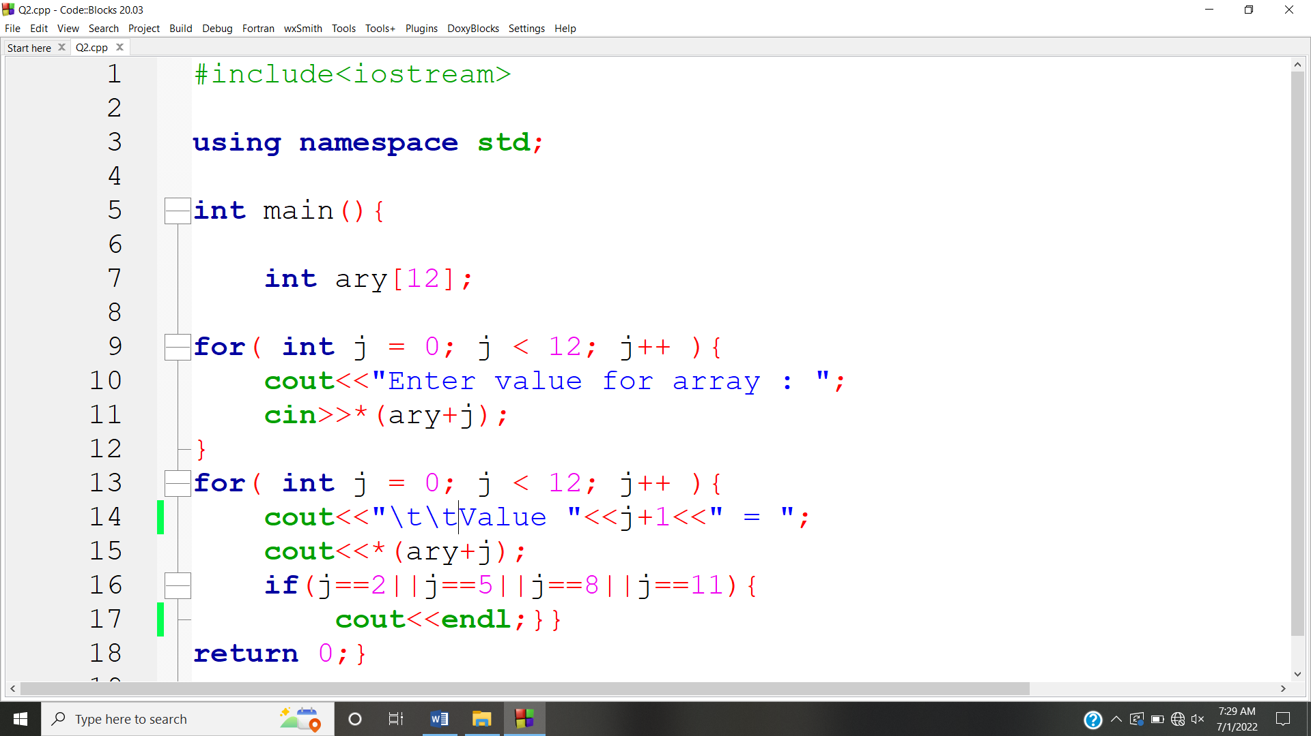

**OUTPUT:** 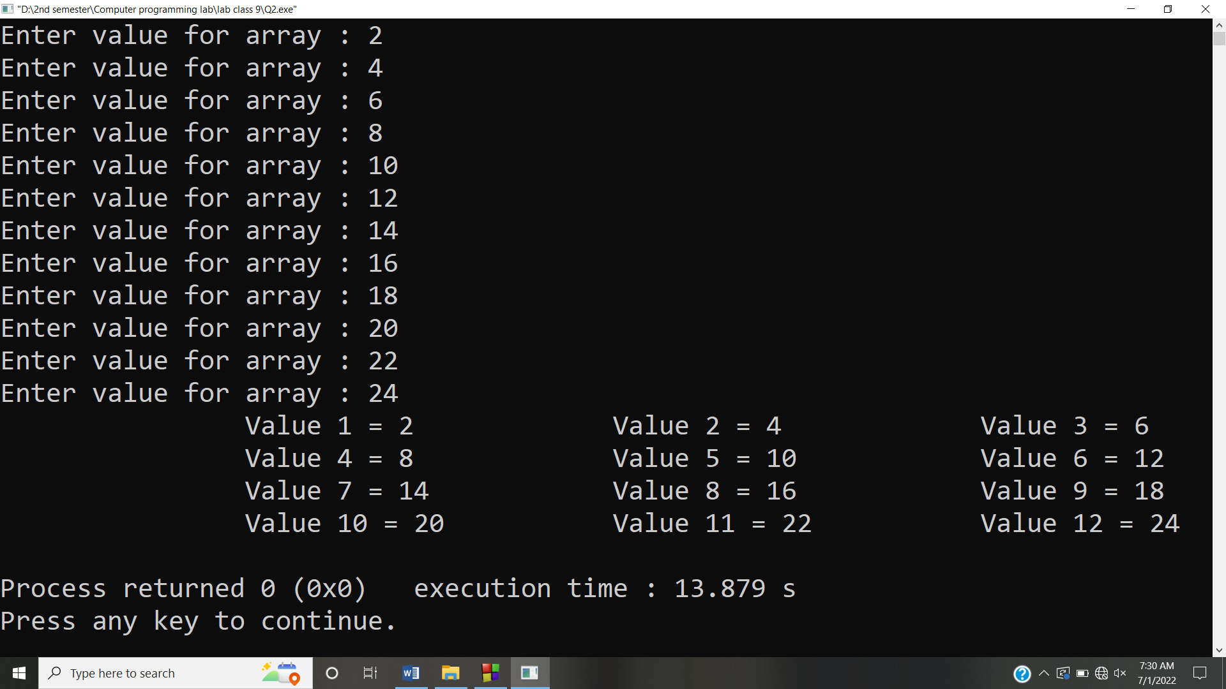

**Answer #3**

**CODE:** 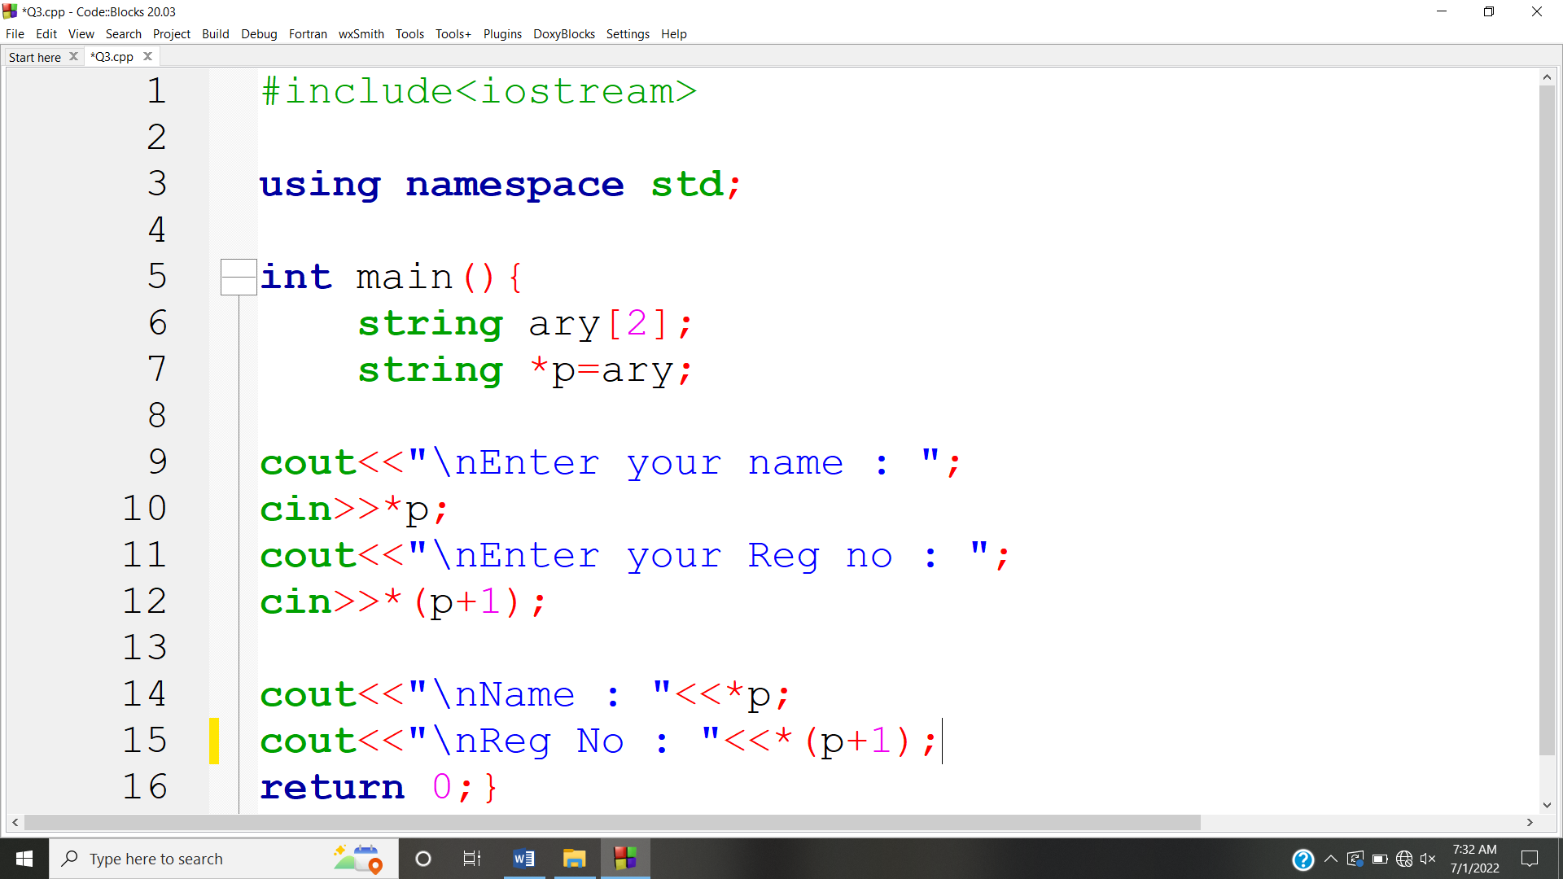

**OUTPUT:** 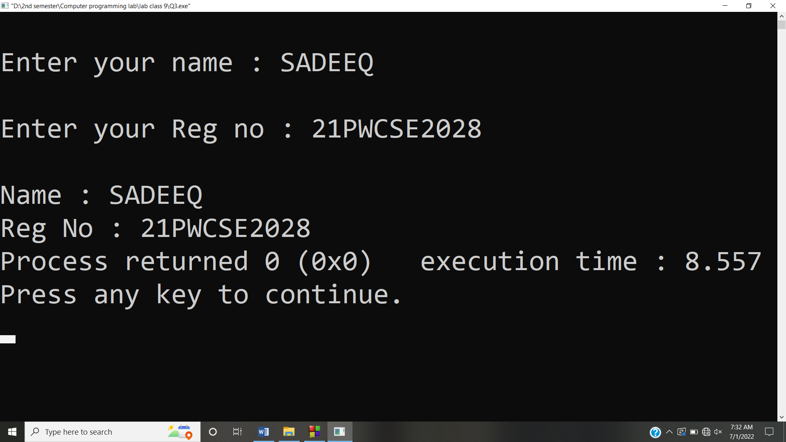

**Answer #4**

**CODE:** 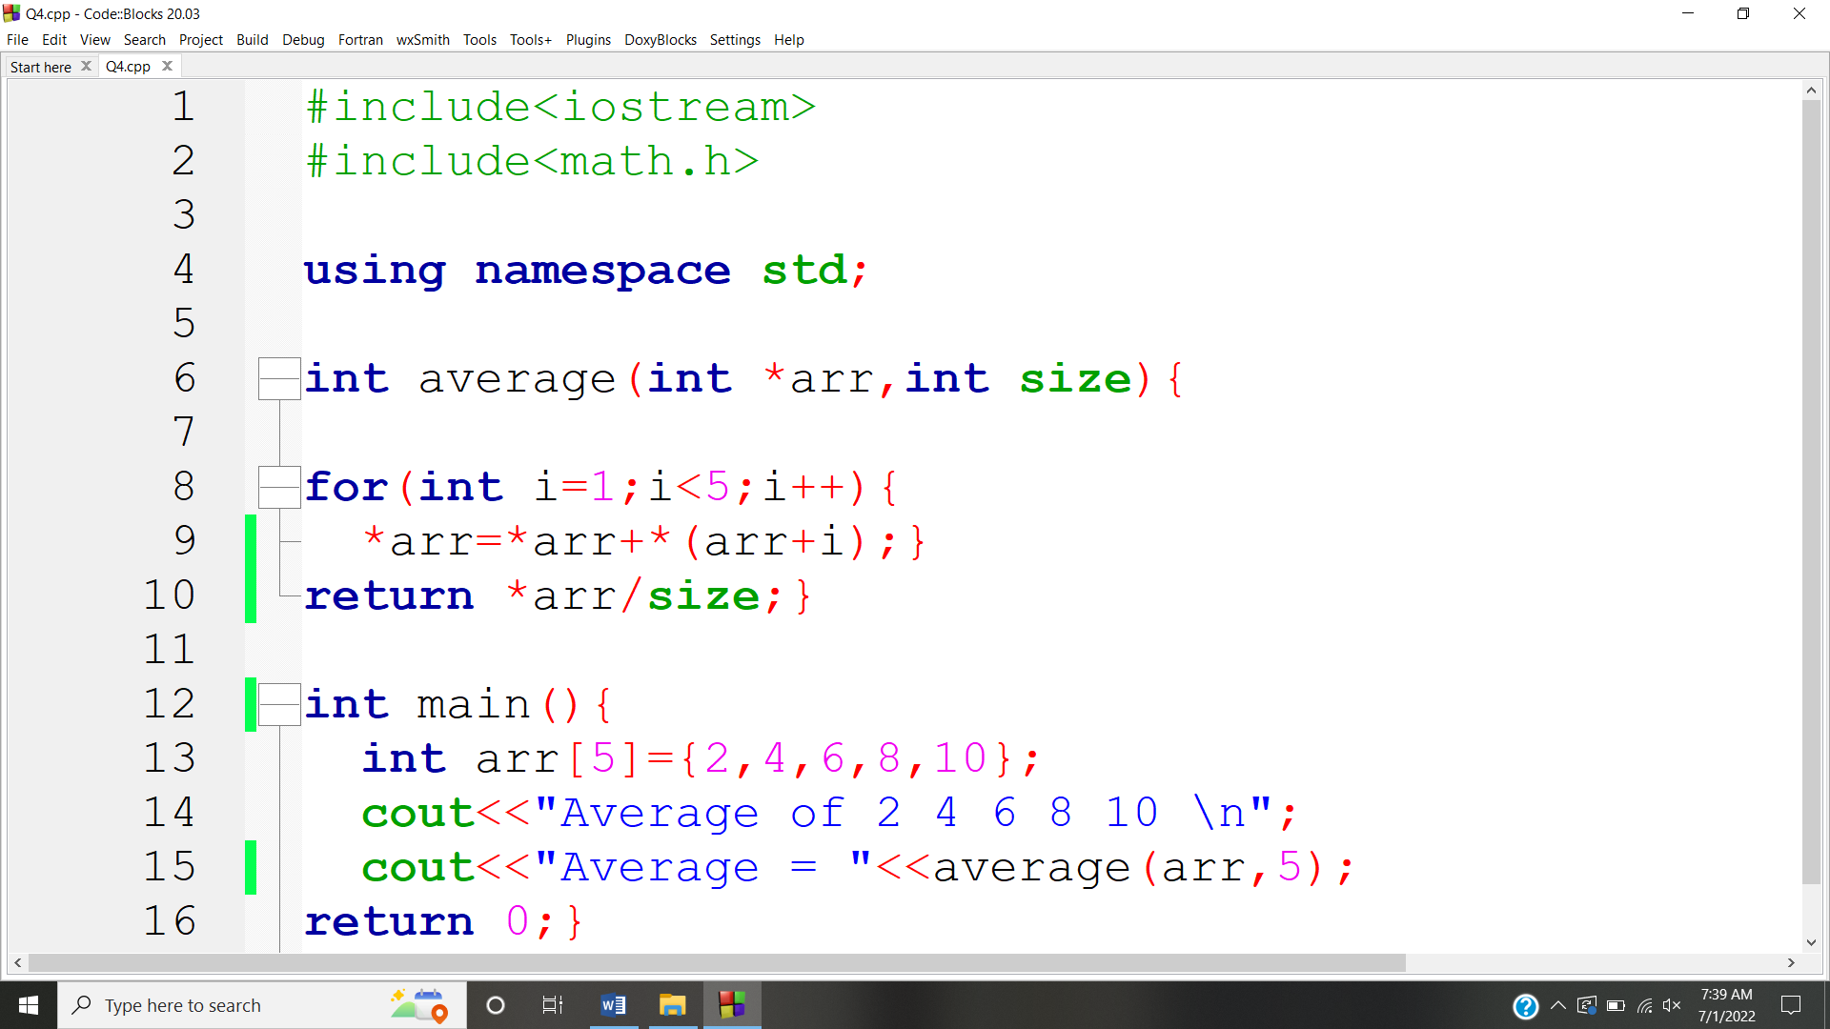

**OUTPUT:** 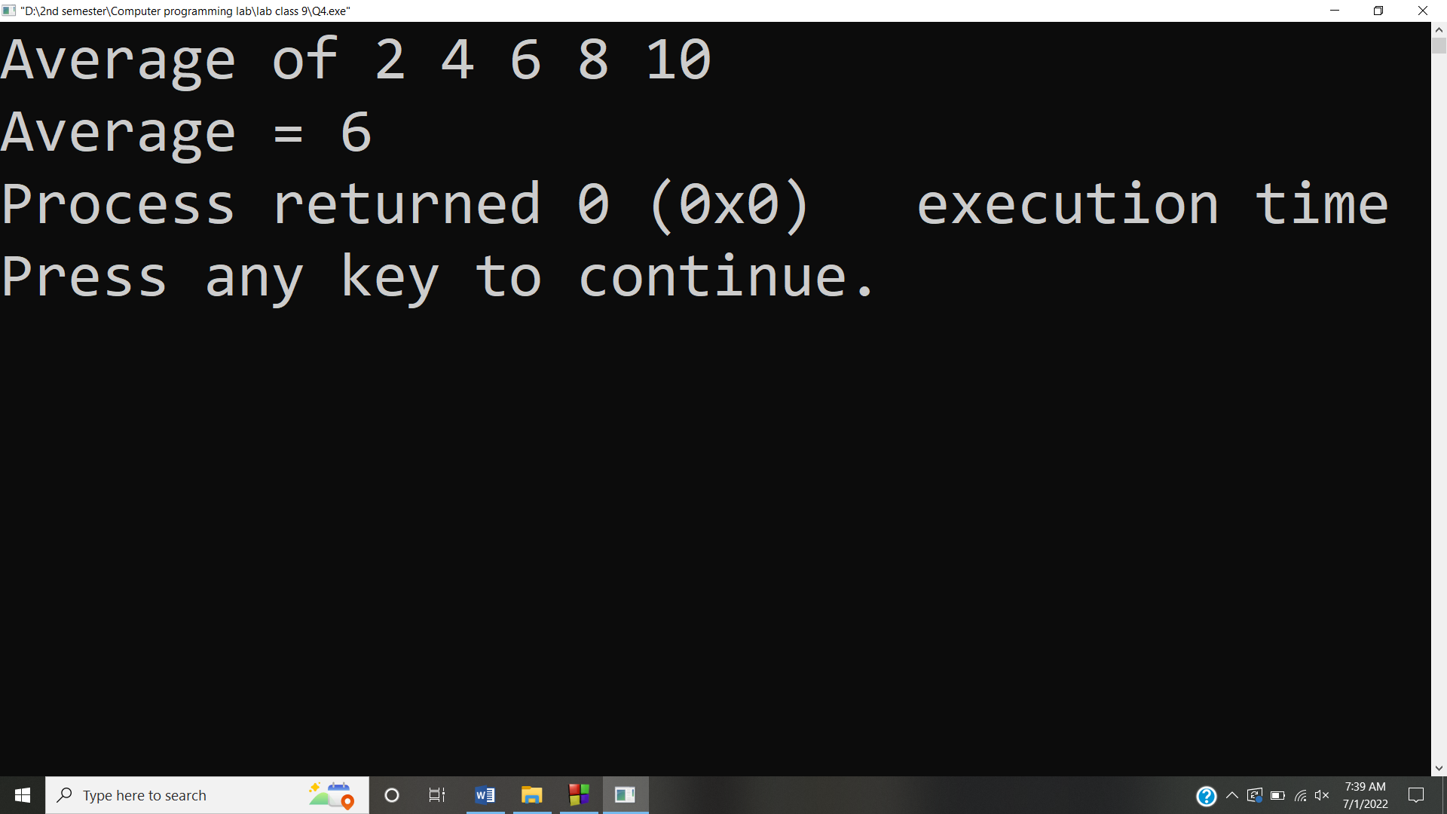

**Answer #5**

**CODE:** 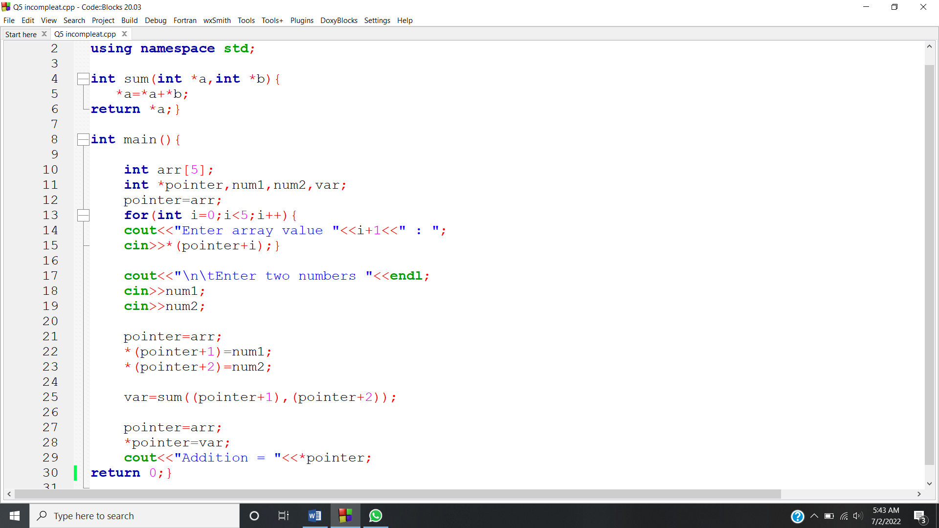

**OUTPUT:** 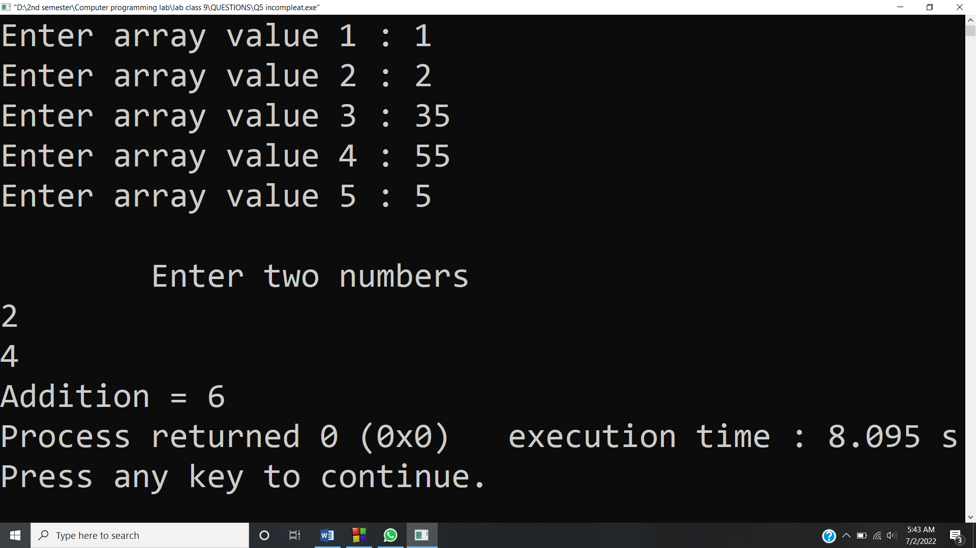

**Answer #6**

**CODE:** 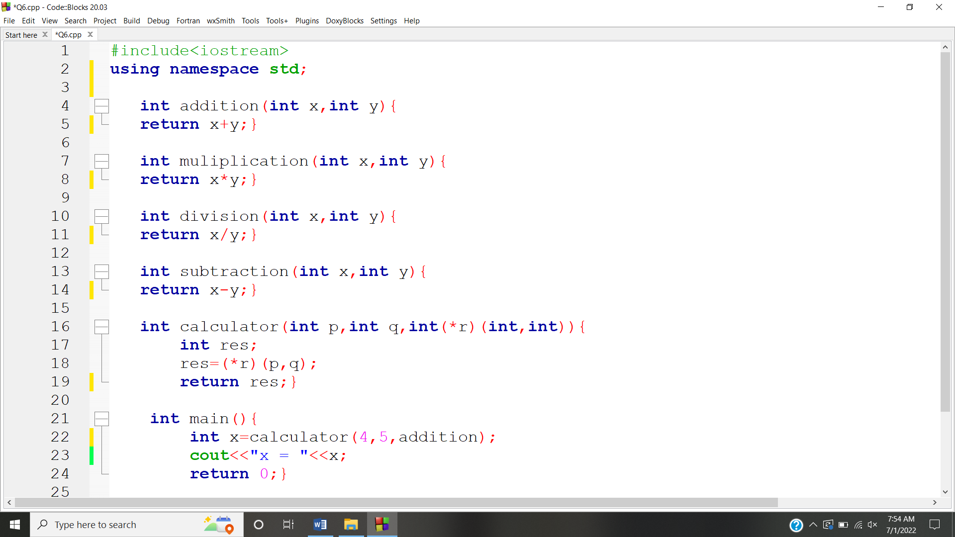

**OUTPUT:** 